# Criteria 5 Design Folio

|  |
| --- |
| **Instructions**  Criterion 5 assesses students’ skills in designing a software solution. Students will generate two or three alternative design ideas, develop evaluation criteria with reference to their design ideas and the software solution and then produce their preferred designs for the software solution.    **Evidence**  Intended to be reviewed and signed off by your client, you will document evidence of their critical and creative thinking through design ideas, solution requirements and justification of preferred designs as part of the Design Stage in Criterion 5 |

## 

## 5.1 Three Design Ideas

### 5.1.1 Design 1 Mock-Ups

|  |
| --- |
| **Instructions**  You should produce a sketch that shows the appearance of the screen or screens. The number of screens you mock-up will be determined by your Evaluation Criteria.  At a minimum, you mock-up should show:   * Position and relative size of controls * Position, size, colours and style of text (headers and body text) * Menu positions, styles and content * Input boxes and their default prompts * Borders, frames, shapes, images, decorations and colour schemes * Object alignment * Content of headers and footers |

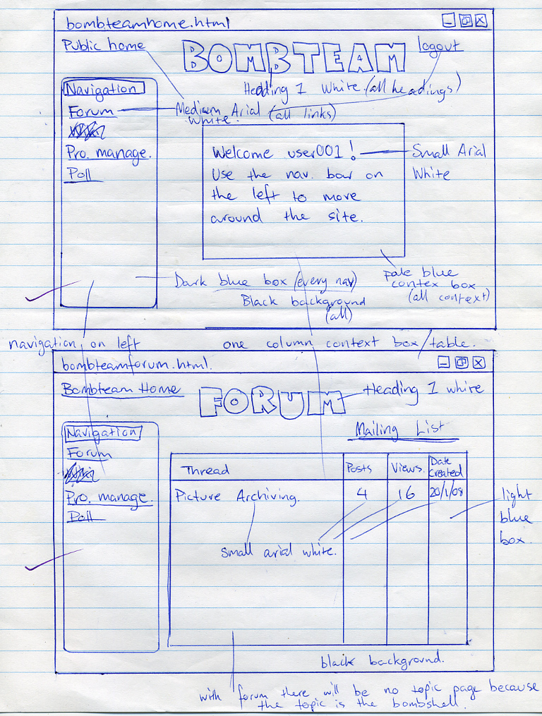

### 5.1.2 Design 2 Mock-Ups

### 5.1.3 Design 3 Mock-ups

### 5.1.4 Data Dictionary

|  |  |  |  |  |  |  |  |
| --- | --- | --- | --- | --- | --- | --- | --- |
| **Name** | **Data Type** | **Format** | **Length** | **Required?** | **Validation** | **Description** | **Sample** |
|  |  |  |  |  |  |  |  |
|  |  |  |  |  |  |  |  |

### 5.1.5 Pseudocode

### 5.1.6 Object Descriptions

|  |  |  |  |
| --- | --- | --- | --- |
| **Object Name** | **Properties** | **Methods** | **Events** |
|  |  |  |  |
|  |  |  |  |

## 

## 5.2 Evaluation of three designs

|  |
| --- |
| **Instructions**  Example Evaluation Criteria  Design Evaluation Rubric Template |

### 5.2.1 Evaluation Criteria

### 5.2.2 Evaluation of each design

## 5.3 Client Feedback

## 5.4 Justification for the chosen design

|  |
| --- |
| **Instructions**  With reference to the evaluation process, explain why you have selected your chosen design. |

Lorem ipsum dolor sit amet, consectetur adipiscing elit. Quisque pretium mattis laoreet. Quisque venenatis dolor eget finibus elementum. Ut euismod egestas velit, eu imperdiet tortor placerat sit amet. Sed quis pellentesque augue. Phasellus nec vestibulum enim. Ut magna leo, vehicula sed ultricies ac, pellentesque id lacus. Aliquam sed urna dignissim, aliquam turpis at, dapibus ex. Quisque non cursus diam. Aenean non euismod turpis, et semper nibh. Maecenas non mi accumsan, viverra mi eu, consectetur libero. Donec iaculis vehicula mollis.

Praesent blandit ac ante ut euismod. Pellentesque neque turpis, semper at risus et, gravida cursus urna. Vivamus bibendum, enim at suscipit consectetur, metus justo semper orci, in convallis arcu dolor at tellus. Nulla faucibus pellentesque diam id aliquam. Pellentesque sed arcu eget nibh sodales consequat. Suspendisse aliquam sem maximus justo tristique ultricies. Mauris vulputate sem nec leo iaculis, vel blandit ligula convallis. Etiam efficitur enim sem. Nunc at augue eu metus.

*2 paragraphs, 150 words, 1029 bytes of Lorem Ipsum*

## 

## 5.5 Detailed Designs

|  |
| --- |
| **Instructions**  You should produce detailed mock-ups that show the appearance of **all** the screens, reports, input and output files of your proposed solution.  At a minimum, you mock-up should show:   * Position and relative size of controls * Position, size, colours and style of text (headers and body text) * Menu positions, styles and content * Input boxes and their default prompts * Borders, frames, shapes, images, decorations and colour schemes * Object alignment * Content of headers and footers |

### 5.5.1 Screens

### 5.5.2 Reports

### 5.5.3 Inputs

### 5.5.4 Outputs